Ideation Phase
Empathize & Discover

Date | 31 January 2025
Team ID
Project Name | DocSpot
Maximum Marks | 4 Marks

Empathy Map Canvas:
Understand the needs, frustrations, and behaviors of doctors ,patients and admin seeking consistent work through a platform like Docspot.
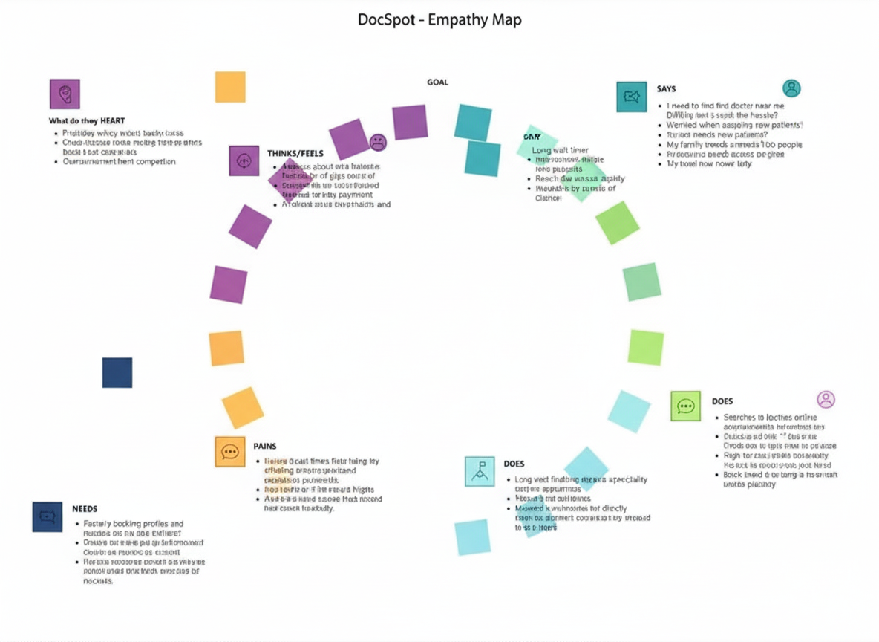

Reference: https://www.mural.co/templates/empathy-map-canvas

